**NAME :** **CAROLINE NYAMBURA WACHIRA**

**EMAIL:** [caroline.nyambura@womentechsters.org](mailto:caroline.nyambura@womentechsters.org)

**DATE**:**04/0/2021**

**QUESTION 1**

**LIST THE PROCESSES FOR THE CURRENT SHELL**

1. Open your Microsoft azure , login and run the virtual machine,
2. Open your ubuntu terminal you can check whom you are and also try neofetch
3. Type in “ PS” to check processes on the current shell

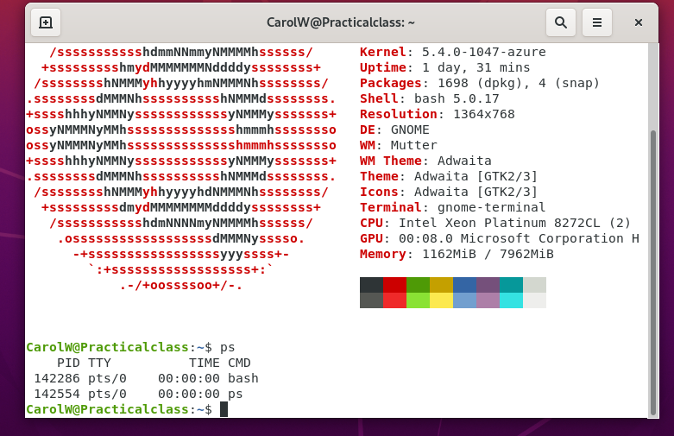

**QUESTION 2**

Display information about processes

1. Use SSH command to log in
2. Type the PS aux command to see the running processes in the linux

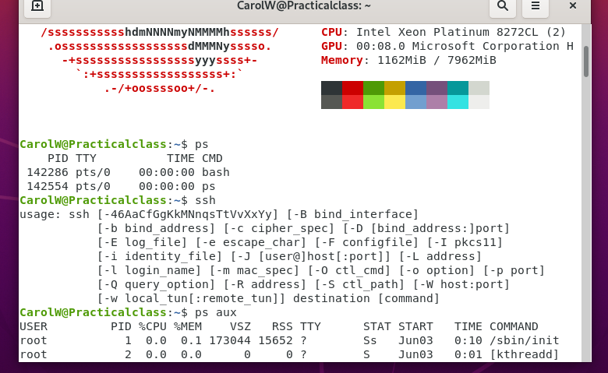

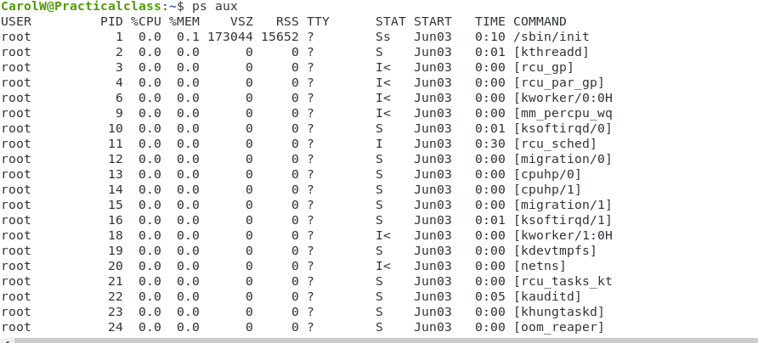

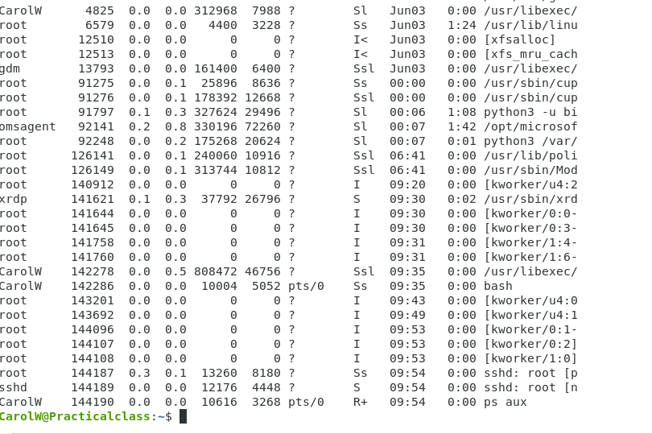

**QUESTION 3**

Display the global priority of a process with default arguments

One can display the global priority process by running the “ ps -ec1“command



**Question 4**

Change the priority of a process with default arguments

We’ll launch a test program called test.pl which will be used to demonstrate nice and renice command

ps -fl -C "perl test.pl" this will be used to show the nice value in default



**Question 5**

Display virtual memory stastistics

We will display using the following command cat /proc/meminfo

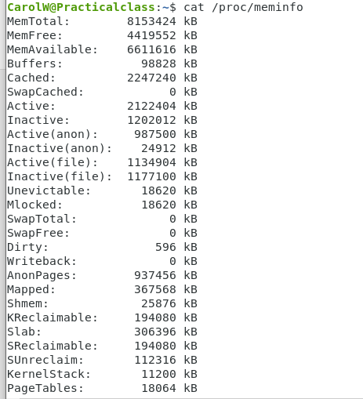

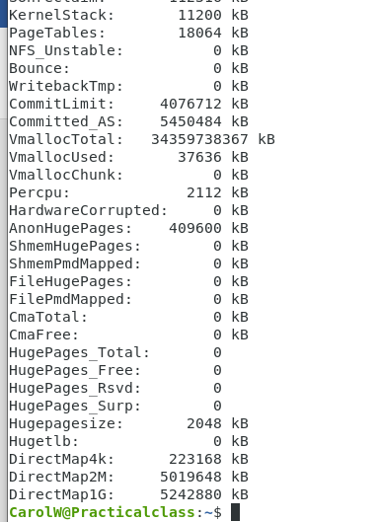

**QUESTION 6**

Display system event information

**Question 7**

Display Swapping Statistics

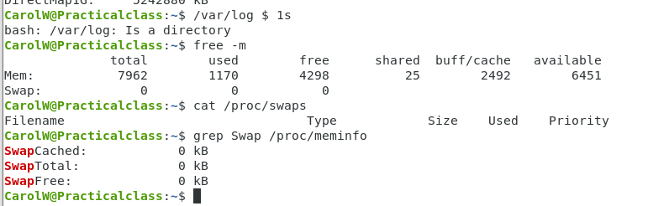

**Question 8**

Check File Access statistics.

**Question 9**

Check Buffer Activity statistics

**“**We use the sar -b”

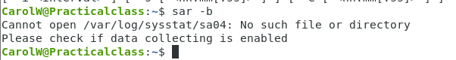

**Question 10**

10. Check Disk Activity statistics

We will use the dstat -d

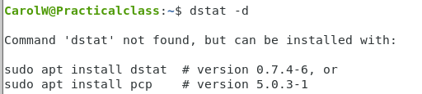

**Question 11**

11.Check Inter process Communication statistics

**Question 12**

Unused memory in server

Will use the command” free”

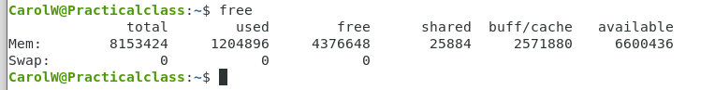

**Question 13**

Check swap activities

1.Open a terminal application.

2.To see swap size in Linux, type the command: swapon -s.

3.You can also refer to the /proc/swaps file to see swap areas in use on Linux.

4.Type free -m to see both your ram and your swap space usage in Linux.

5.Finally, one can use the top or htop command to look for swap space Utilization on Linux too.

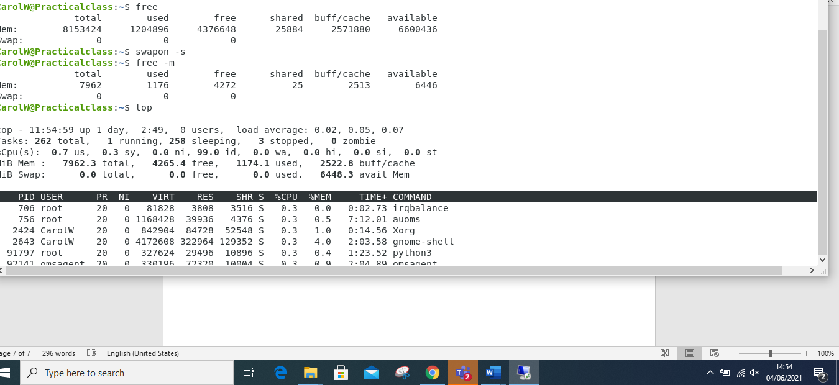

**PRACTICAL ACTIVITY PART 2**

**QUESTION 1 and 2 combined**

Create a user account called user1 and another user2,

Ensure they are password protected

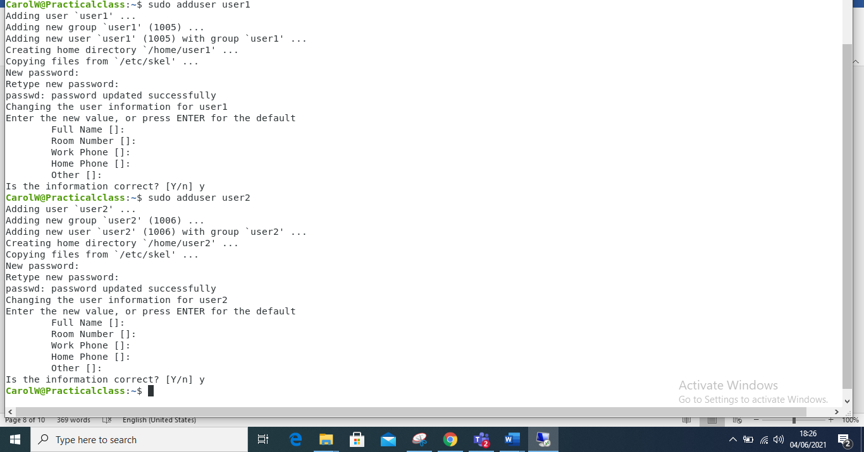

**Question3**

Logging out

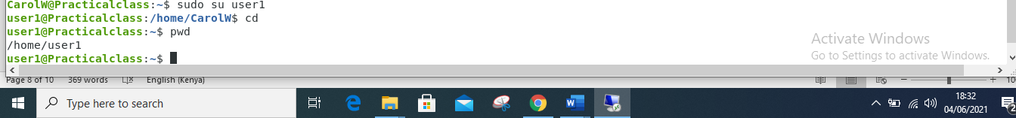

**Question 4**

Create a testdir

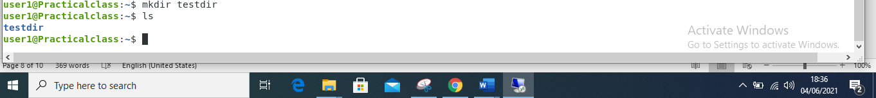

**Question 5**

Create a file testfile in testdir

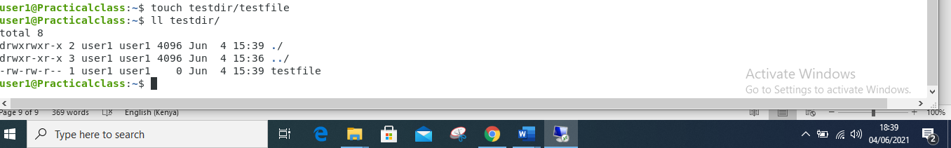

**Question 6**

Verify the ownership and the group of the testfile



**Question 7**

Switch to Superuser account

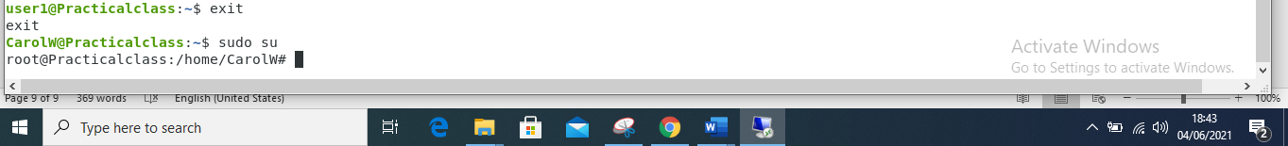

**Question 8**

Create a public directory dir1

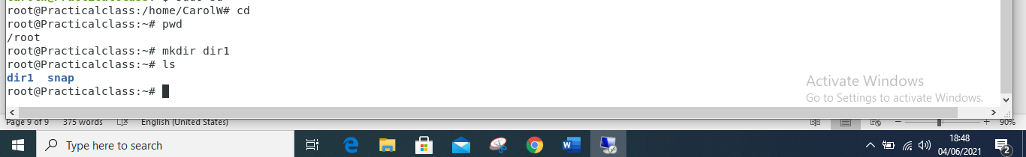

**Question 9**

Set stickybit (save text attribute) on dir1

